CREATE EVENT*

Event creators can record a new accomplishment, contact or event using this create event Menu. In the events, Results & Accomplishments: New Information Form page users can describe their event details and based on the details provided event reports are generated.
*For purposes of this explanation “EVENT” is a term used to describe any action, contact, accomplishment or event that a recorder documents in T/MC OHATS

To expand your understanding of OHATS TMC and the recorder goals, read this 2002 overview: http://www.tutormentorexchange.net/OHATS/Reports/TMC_OHATS_Report_Sep-00_thru_Mar-02.pdf
 | Recorder name can be chosen from the list of existing names or a new recorder can be added through the “Add New” link
 | If you check this box, events will not be listed to public. It is available for the logged users only
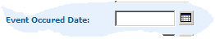 | Specify the Date on which the event took place, or began
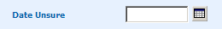 | If you are not sure when the event happened then choose an approximate date for when the event took place
Specify the source of the Event. By default the event source will be set as “Internal” All internal and external events will be listed separately in the Main page.
Define difference - Ganesh
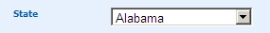 | Choose a state in which an event or action took place, or where the primary contact is located. E.G. if you had a meeting with someone from New York City, choose New York, from the list of states where the event is scheduled to happen.  Need to be able to choose countries, too.
 | Sponsor is not needed. Can you change this box to COUNTRY? Give the name of the Sponsor who sponsors the event
 | Not needed. The box on State and Country would cover location. Specify the Location where Event is scheduled to take place
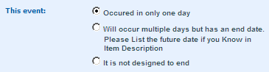 | Options for capturing event period  - “Occurred in only one day” if the events occurs on only one day.  - Choose “Multiple days but has an end date” option if the event is scheduled to occur on more than one day but has a scheduled end date.  - Choose “It is not designed to end” if the event is a never ending event.
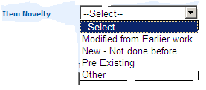 | Item Novelty tells about the item innovation. The item can be a new item or an existing one or may be a modified from the earlier work. Choose one of the options to specify about the nature of your Item.
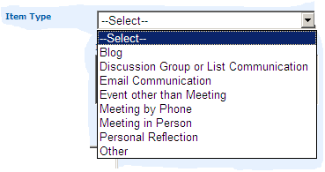 | This section describes contacts, which may or may not lead to accomplishments or events in the future. You do not need to document every contact, but if you have a purpose for contacting someone, you can show the nature of that contact here.  Choose an item type from the list of item types.  Note: this feature was not in the 2000-2007 version of OHATS TMC.
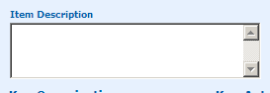 | Give a description about your item. Briefly outline what happened so that people outside your organization can understand the nature of your accomplishment, contact or event.
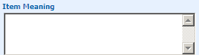 | Give the Meaning for your item. I.e. Describe why and how this event is important to the mission, objectives or work of the organization. Look at the choices in the EVENT GOALS section. All actions should related to one or more event goals, or a new goal should be stated.
Did I delete a box here? | ITEM RESULT: State the outcome or predict future results or consequences as a result of the recorded event.  NUMBER OF PEOPLE INVOLVED  Can you create a new box that allows us to put in the number of people in a meeting, or event? When I document a conference, for instance, I can’t list all 200 people who attended. If I can reference a list, and put a number. Then that would help show the scope of the event or meeting.
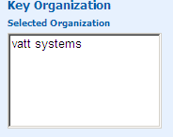 | Ganesh. This should come after Key Actors.  In this section you are listing the organizations involved in the event you are describing. By default when an actor is chosen the actor’s organization will be loaded. If you have worked with this actor or organization previously, you will be able to pull it from the list of organizations already on-line.
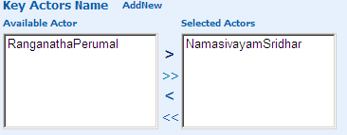This can become time consuming as the list grows | List the key person(s) involved in the event you are describing. If you have listed a person previously, the name will be in the “Key Actors Name” list. You can choose an actor of your choice or add an actor through the “Add New” link.

EVENT GOALS
The OHATS T/MC is intended to document actions that lead to a desired long-term outcome. The major categories within the Tutor/Mentor Connection mission and action plan are the event goals listed below. As you describe and event, think of the impact of your action on one or more of these goals. An Event Recorder can choose any of these goals or state their own goals other than the listed goals. More than one goal can be chosen for an event.
Read more of mission and goals: http://cmapspublic.ihmc.us/servlet/SBReadResourceServlet?rid=1180119458133_1125501099_34173&partName=actualhtmltext
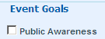 | Check this check box if the item relates to public awareness i.e. related to media(TV, Radio, print, cable, web)
 | Check this check box if the event goal is related to the organization’s use of technology to achieve goals..
 | Check this check box if the event goal is related to research, best practices, program locator search, and/ or evaluation
 | Check this check box if the event goal is related to training, education, and/or helping people understand and use the information T/MC collects and shares
 | Check this check box if the event goal is related to Resource Development and Capacity Building, eg. namely bringing in/developing people and organization helping tutor/mentor programs throughout Chicago get volunteers, dollars, training, and other resources needed to mentor kids to careers.
 | Check this check box if the event goal is related to one or more of the events, services or products the T/MC has created, such as conferences, recruitment fairs, etc.
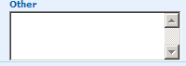 | If the event goal is other than the specified list of goals stated the event goals in the above, describe your goal in this other text box.

EVENT TYPE – MEASURE OF COMMUNITY CHANGE
A Community Change is an observable change in the environment that indicates a new or modified program, policy or practice of an organization or system. A reported item is counted as a community change if it is facilitated by the organization under study (Tutor/Mentor Connection), is important to the mission of that organization, and influences or engages people or organizations outside of that organization. (read more at http://www.tutormentorexchange.net/OHATS/Reports/TMC_OHATS_Report_Sep-00_thru_Mar-02.pdf )

Once you describe what part of the T/MC mission your event affects, select the box of one or more of the following categories that best describes this event. You can check more categories. If you select more than one category, rate the relative priority, on a scale of 1-10. 1 being the lowest and 10 being the highest. By default the rank will be stored as 10. Thus if you check “media” and “community system change” which was more important in your opinion. If equal in importance, give each a “5”. Steve, Ganesh, this is extremely subjective to interpretation. Do we want this?

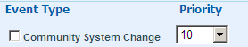 | Check this check box if the event resulted in a creation or modification of any community or system.
 | Check this check box if the event resulted in media related to your organization.
 | Check this check box if the event resulted in Community action or change
 | Check this check box if the event resulted in funding, materials and services to your organization.
 | Check this check box if the event resulted in offering or providing a service by your organization to a person, client, or group
 | Check this check box if the event result was an event or action to plan or develop your organization or its related work
 | Check this check box if the event result was an event or action that positively or negatively influenced your organization or its work.
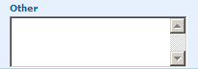 | If your event type is other than the specified event types specify it in the “Other” text box area.

EVENT COMMUNICATION
In this section you can help organize the information you document for future reports and analysis. You can choose a communication type from the list or specify your own communication type. You can choose more than one communication type.
Ganesh. Does this affect what gets put on the metrics charts?

 | Check this check box if the event has to be included in organizational reports or related document.
 | Check this check box if the event is a special event.
 | Check this check box if it is a best practice.
 | Check this check box if the you want to share this event through mail.
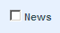 | Check this check box if the event can be shared through news or through media
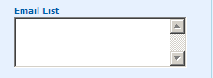 | You can specify the list of e-mails separated by comma with whom you want to share.
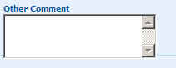 | Other comments related to event communication can be given here.

UPDATE EVENT
- Event details, Results and Accomplishments can be updated using the edit icon in the Event home page or from the Search page.
- While updating the event details we can add a new recorder name, change the existing recorder name, add a new actor to the event or change the actor.
- We can change the item novelty, and Change the Item type.
- Event type, Event goal and Event communication can also be changed.

(will we be able to go back to the data we are transferring from the 2000-2007 OHATS and update that information?)

